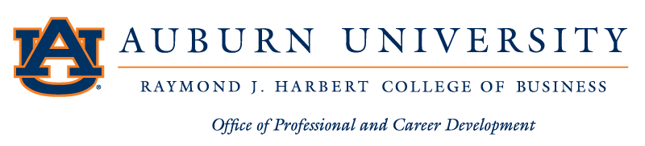

Parking Pass
Event: Harbert College of Business Career Fair
Date: September 24th, 2024
Purpose: Employer Participant Approval: Arishna Lastinger

Contact: Office of Professional and Career Development
Lowder Hall – 334-844-7203

